MOBILE APPLICATION DEVELOPMENT

CYCLE 2

Anunadh Rajesh
S3MCA
20MCA015

1.Create 2 activity from the first activity on a button click move to the second activity.

Program

xml
activity_main.xml

LinearLayout android:layout_width="match_parent" android:layout_height="match_parent"
android:orientation="vertical"
android:gravity="center"
xmlns:android="http://schemas.android.com/apk/res/android">
<Button
android:layout_width="wrap_content"
android:layout_height="wrap_content"
android:text="MOVE TO NEXT ACTIVITY"
android:id="@+id/bt"
android:onClick="click"
android:gravity="center"/>
</LinearLayout>
activity_main2.xml
<LinearLayout android:layout_width="match_parent" android:layout_height="match_parent"
android:orientation="vertical"
android:gravity="center"
android:background="@android:color/holo_blue_light"
xmlns:android="http://schemas.android.com/apk/res/android">
<TextView
android:layout_width="wrap_content"
android:layout_height="wrap_content"
android:text="WELCOME TO THE SECOND ACTIVITY"
android:id="@+id/tv" />
</LinearLayout>
Java
mainActivity.java
package com.example.sjcet.que12activ;
import android.content.Intent;
import android.widget.Button;
import android.view.View;
import android.support.v7.app.AppCompatActivity;
import android.os.Bundle;
public class MainActivity extends AppCompatActivity {
Button bt;
protected void onCreate(Bundle savedInstanceState) {
super.onCreate(savedInstanceState);
setContentView(R.layout.activity_main);
bt =findViewById(R.id.bt);
}
public void click(View view) {
OpenNewActivity();
}
public void OpenNewActivity()
{
Intent intent=new Intent(this, Main2Activity.class);
startActivity(intent);
}
}
mainActivity2.java
package com.example.sjcet.que12activ;
import android.support.v7.app.AppCompatActivity;
import android.os.Bundle;
public class Main2Activity extends AppCompatActivity {
@Override
protected void onCreate(Bundle savedInstanceState) {
super.onCreate(savedInstanceState);
setContentView(R.layout.activity_main2);
}
}Output
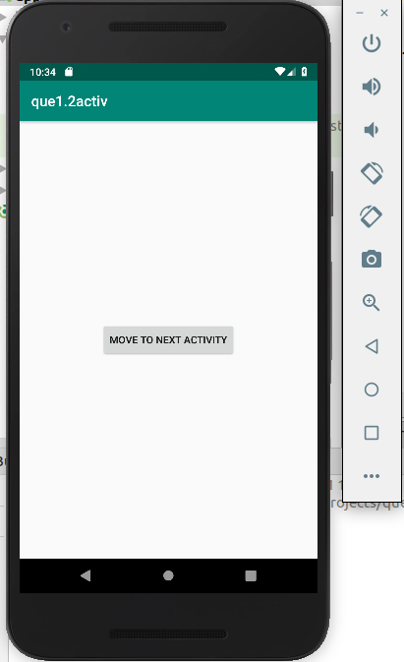
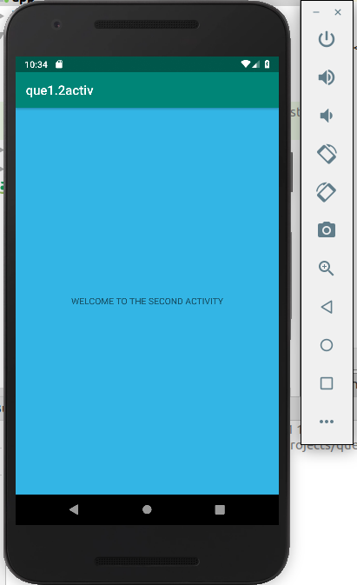

2.create an activity and move to fb loginpage on button click

Program

XML
<LinearLayout android:layout_width="match_parent" android:layout_height="match_parent"
android:orientation="vertical"
android:gravity="center"
xmlns:android="http://schemas.android.com/apk/res/android">
<Button
android:layout_width="wrap_content"
android:layout_height="wrap_content"
android:text="MOVE TO FB PAGE"
android:id="@+id/bt"
android:onClick="click"
android:gravity="center"/>
</LinearLayout>

Java

package com.example.sjcet.facebook;

import android.content.Intent;
import android.net.Uri;
import android.support.v7.app.AppCompatActivity;
import android.os.Bundle;
import android.view.View;
import android.widget.Button;
public class MainActivity extends AppCompatActivity {
@Override
protected void onCreate(Bundle savedInstanceState) {
super.onCreate(savedInstanceState);
setContentView(R.layout.activity_main);

Button btn_Explicit = (Button)findViewById(R.id.bt);
btn_Explicit.setOnClickListener(new View.OnClickListener() {
@Override
public void onClick(View view) {

Intent intent = new Intent(Intent.ACTION_VIEW,Uri.parse("https://www.facebook.com/"));
startActivity(intent);
}
});
}
}
OUTPUT
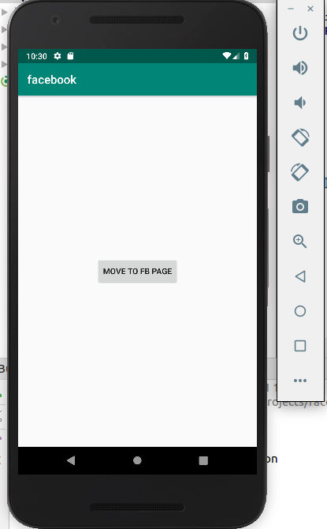
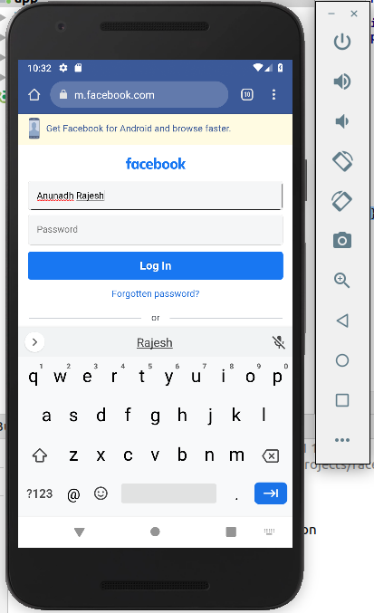

3.Read message in first activity and pass it to the second activity to the button click

Program

xml
activity_main.xml
<LinearLayout android:layout_width="match_parent" android:layout_height="match_parent"
android:orientation="vertical"
xmlns:android="http://schemas.android.com/apk/res/android">
<EditText
android:layout_width="match_parent"
android:layout_height="wrap_content"
android:id="@+id/et"
android:textColor="@android:color/holo_red_dark"/>
<Button
android:layout_width="wrap_content"
android:layout_height="wrap_content"
android:text="MOVE TO NEXT ACTIVITY"
android:id="@+id/bt"
android:onClick="click"
/>
</LinearLayout>

activity_main2.xml
<LinearLayout android:layout_width="match_parent" android:layout_height="match_parent"
android:orientation="vertical"
android:gravity="center"
xmlns:android="http://schemas.android.com/apk/res/android">

<TextView
android:layout_width="match_parent"
android:layout_height="wrap_content"
android:id="@+id/tv"
/>

</LinearLayout>
Java
mainActivity.java
package com.example.sjcet.readpassmsg;
import android.content.Intent;
import android.support.v7.app.AppCompatActivity;
import android.os.Bundle;
import android.view.View;
import android.widget.Button;
import android.widget.EditText;
public class MainActivity extends AppCompatActivity {
Button bt;
EditText et;
protected void onCreate(Bundle savedInstanceState) {
super.onCreate(savedInstanceState);
setContentView(R.layout.activity_main);
bt =findViewById(R.id.bt);
et =findViewById(R.id.et);
}
public void onClick(View v) {
String str = et.getText().toString();
Intent intent = new Intent(getApplicationContext(), Main2Activity.class);
intent.putExtra("message_key", str);
startActivity(intent);
}
}
mainActivity2.java
package com.example.sjcet.readpassmsg;

import android.widget.TextView;
import android.content.Intent;
import android.support.v7.app.AppCompatActivity;
import android.os.Bundle;
public class Main2Activity extends AppCompatActivity {
TextView tv;
@Override
protected void onCreate(Bundle savedInstanceState) {
super.onCreate(savedInstanceState);
setContentView(R.layout.activity_main2);
tv =findViewById(R.id.tv);
Intent intent = getIntent();
String str = intent.getStringExtra("message_key");
tv.setText(str);
}
}
OUTPUT
